### 

## Computer Science Department

## Database Management Systems 333

**Project Phase 2**

**Idea for:**  Law Office

**Group No:** 8

**Student Names:** Tariq Odeh – 1190699

Qays Safa – 1190880

Mahmoud Samara – 1191602

## Summary

This project will be Law Office, since the courts had become an important matter at this time. The idea of this project came to us because lawyers and people who file cases face a problem in knowing the details of their cases and their dates, so we decided to create an application that arranges all those cases and appointments for the user, whether he is an employee inside the office or a customer. Our client is lawyer Fakhri abu bishara he has a law office in Tubas city.

## Introduction

This is a Law Office Database for lawyer Fakhri abu bishara manager of law office in Tubas city, that providing various legal services. The client used to provide legal services and save and arrange dates and information for each case separately in paper form and non-computerized. And one of the problems faced is the inability to save and arrange dates and information for each case separately, and there are also problems with clients that they do not remember the date and information of their cases, so they miss their appointment without knowing. Our database system will help our client to facilitate and arrange all dates and information for each case separately, also save all dates for client to remember the date and information of people cases thus the office won’t need to spend many hours daily to arranging dates and information, so this will lead to save effort and time for both the customer and the employee.

## Data Requirements

* The lawyer has his name, ID number, address, phone number, email registered, password and gender.
* The Plaintiff (المدعي) has his name, ID number, address and phone number.
* The Defendant (المدعى عليه) has his name, ID number, address and phone number.
* Cases have case number (ID), case number in the court. And the cases are separated into four types. The first type is rights cases that has file state, court type and the case description. The second type is penalty cases has penalty type, court type and the case description. The third type is Resumption cases has case description. The fourth type is execution cases has case description.
* The payment has payment_ID, Payment method, currency.
* Date has Date_ID, Date of session, Time
* Notifications have Notification_ID, Notification_Date, Notification Method.
* Every lawyer can claim for one or more Plaintiff (المدعي) and can deal with one or more cases. On the other hand, each case has a specific lawyer and has one or more Plaintiffs.
* There is a lawyer who is the manager he can manage one or more lawyers (employees) in the office.
* Every lawyer can defend for one or more Defendants (المدعى عليه) and can deal with one or more cases. On the other hand, each case has a specific lawyer and has one or more Defendants.
* The lawyer gets one or more payment from cases, and each case is paid for it one or many times for the lawyer.
* Each case have to happen in one or more Dates, and the same date can be for one or more cases.
* Each case can get one or more Notifications for it, but the Notifications has to be for a specific case.

## ER Diagram

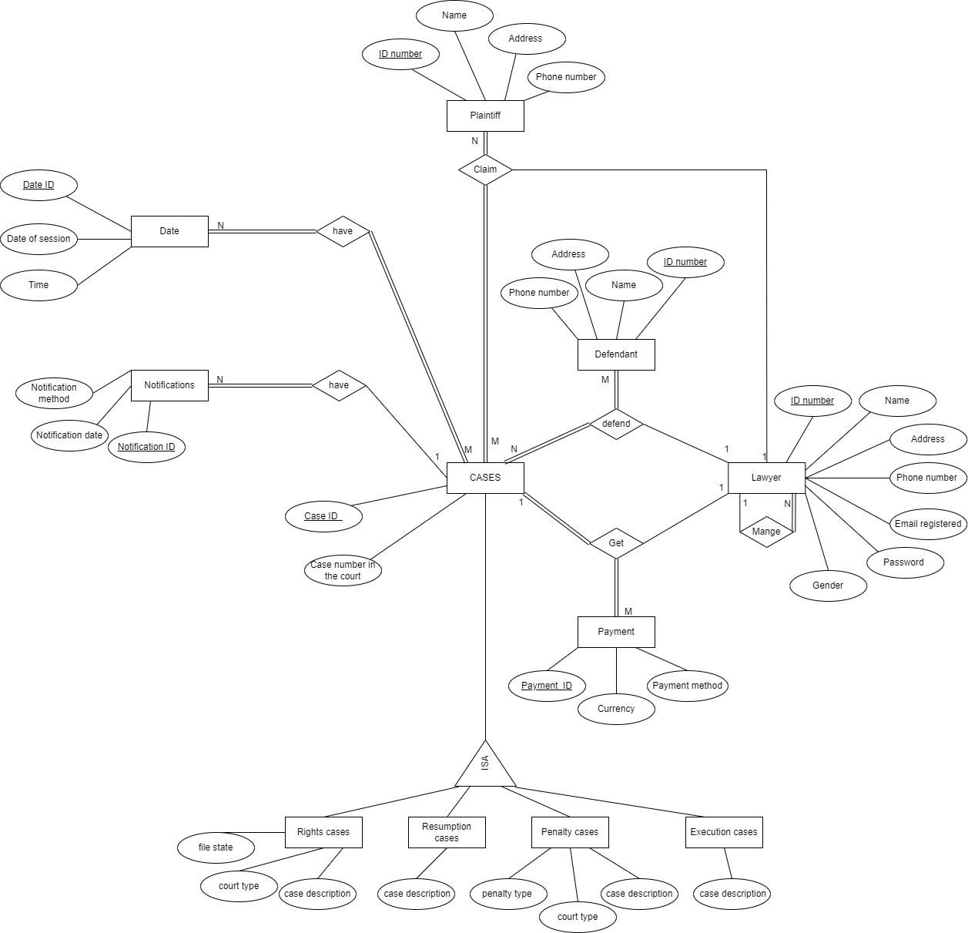

## Technology

In our project we will use java language (Eclipse, JDK 17.0.2), HTML, CSS, JavaScript, also we will use java FX, scene builder and finally for Database System: we will use SQL language, MySQL workbench.